Medical Appointment and Scheduling System for Family Diagnostic Center

A Capstone Project
Presented to the Faculty of the
College of Information Technology Education
PHINMA University of Iloilo

In Partial Fulfillment
of the Requirements for the degree
Bachelor of Science in Information Technology

By:
Florence D. Facton
John Cedric A. Cabillon
Missy F. Jimenez

April 2026

Approval Sheet
In partial fulfillment of the requirements for the Bachelor of Science in Information Technology, this Capstone Project entitled “MASSFDC: Medical Appointment and Scheduling System for Family Diagnostic Center” prepared and Submitted by Florence D. Facton, John Cedric A. Cabillon and Missy F. Jimenez, who are hereby recommended for corresponding final evaluation.
Kristille Mae C. Velasco
Adviser
Approved by the Panel of Evaluators with a grade of PASSED

Dr. Arnold M. Fuentes, Ph. D, MPA, MMIT
Chairman
Ryan C. Valeriano
Member

Accepted in partial fulfillment of the requirements of the degree Bachelor of Science in Information Technology

Seth dA. Nono, MSCS
CITE, DEAN

ACKNOWLEDGEMENT
First and foremost, we give our utmost thanks to God Almighty for His divine guidance, strength, and wisdom throughout the journey of this capstone project. Without His blessings, this endeavor would not have been possible.
We extend our sincere appreciation to our advisor, Kristille Mae N. Velasco, for her invaluable guidance, continuous support, and constructive feedback. Their expertise and encouragement have been instrumental in shaping our research and findings.
We are also grateful to our faculty members at CITE Department, PHINMA – University of Iloilo for their dedication and for equipping us with the necessary knowledge and skills that have played a significant role in the execution of this project.
Finally, a heartfelt thank you to our families and friends for their unwavering support, patience, and encouragement. Their motivation has been a source of strength and perseverance throughout this journey.
This capstone project is the culmination of hard work and dedication. We are truly grateful to everyone who has been a part of this journey.
ABSTRACT
The increasing demand for accessible and efficient healthcare services highlights the need for digital solutions that streamline patient–assigned personnel interactions. This capstone project, entitled “Medical Appointment and Scheduling System for Family Diagnostic Center,” aims to design and develop a user-friendly web-based platform that simplifies the process of booking medical appointments, managing schedules, and facilitating communication between patients and assigned personnel.
The system addresses common challenges in traditional appointment methods, such as long waiting times, overlapping schedules, and difficulty in tracking patient records. Through the platform, patients can easily register, view available assigned personnel and their specializations, and book appointments at their preferred times. For administrators, the system provides efficient tools to manage schedules, monitor patient appointments, and reduce the likelihood of conflicts or double bookings. Additionally, it incorporates automated notifications and reminders to ensure patients are updated about their appointments, minimizing missed consultations.

TABLE OF CONTENTS
Title page ----------------------------------------------------i
Approval Sheet------------------------------------------------ii
Acknowledgement----------------------------------------------iii
Abstract------------------------------------------------------iv
Table of Contents----------------------------------------------v
List of Figures-----------------------------------------------vi
List of Tables-----------------------------------------------vii
CHAPTER I
Introduction---------------------------------------------------
Background of the Study----------------------------------
Statement of the Problem---------------------------------
Objectives of the Study----------------------------------
Significance of the Study--------------------------------
Scope and Limitation-------------------------------------
CHAPTER II
Literature Review----------------------------------------------
Overview---------------------------------------------------
Traditional VS Modern System-------------------------------
Technology Use---------------------------------------------
Case Studies-----------------------------------------------
CHAPTER III
Methodology----------------------------------------------------
Research Design---------------------------------------------
Model Use---------------------------------------------------
Data flow Diagram-------------------------------------------
Entity Relationship Diagram---------------------------------
CHAPTER IV
Result and Discussion------------------------------------------
System’s Features-------------------------------------------
Implementation Challenges-----------------------------------
User Feedback-----------------------------------------------
Comparison to other System----------------------------------
CHAPTER V
Conclusion and Recommendation----------------------------------
Conclusion--------------------------------------------------
Recommendation----------------------------------------------
Final Thoughts----------------------------------------------
CHAPTER VI
Appendices------------------------------------------------------
Screenshots-----------------------------------------------------
Curriculum Vitae-----------------------------------------------
Grammarian Certificate-----------------------------------
Chapter I
INTRODUCTION OF THE STUDY
Healthcare centers today face growing challenges in managing patient appointments efficiently. Traditional scheduling methods, such as walk-ins and manual logbooks, often result in long queues, miscommunication, double bookings, and wasted time for both patients and medical staff. These issues not only affect the quality of healthcare service but also increase the workload of administrators who must constantly update and monitor appointments manually.
The goal of this capstone project, entitled ‘Medical Appointment and Scheduling System for Family Diagnostic Center,’ proposes a web-based platform designed to enhance the process of booking and managing diagnostic appointments. The system enables patients to create an account, browse available offers and their specializations, and reserve appointments at their convenience. At the same time, it provides aligned personnel with an organized scheduling interface that helps avoid overlapping appointments, track patient visits, and manage availability in real time.
The system includes automated reminders, notifications, and patient record management to minimize missed appointments and ensure accurate scheduling. By using technology in the scheduling process, the project aims to improve efficiency, reduce waiting time, and provide a more organized and reliable service for the Family Diagnostic Center.

TECHNICAL BACKGROUND OF THE STUDY
Healthcare services play a vital role in ensuring the well-being of individuals, yet many medical institutions still rely on manual systems for handling appointments and patient records. The Family Diagnostic Center is one such facility that faces challenges with traditional scheduling methods, where patients either walk in or call to secure a consultation. This process often leads to inefficiencies such as long waiting times, overlapping appointments, miscommunication, and administrative delays. These issues negatively affect not only the patient experience but also the productivity of doctors and staff.
With the rise of technology in the healthcare sector, many institutions have begun adopting digital systems to address these problems. Online appointment and scheduling platforms have been proven to improve efficiency, reduce human error, and provide convenience to both patients and medical personnel. They also allow healthcare centers to manage patient data systematically and ensure better monitoring of appointments.
This study, entitled “Medical Appointment and Scheduling System for Family Diagnostic Center,” was conceptualized to provide a web-based solution that simplifies the process of booking and managing diagnostic appointments. By introducing features such as automated scheduling, reminders, and organized patient records, the project aims to replace the center’s manual system with a more efficient and reliable approach to healthcare service delivery.

STATEMENT OF THE PROBLEM
Patients at FDC sometimes experience delays when booking their appointments because the only way to contact the clinic is through Facebook. Replies often take time since the person managing the page also has other tasks to do. Sometimes, patients even have to go to the clinic in person just to ask about the services offered and their prices, which can be quite inconvenient for them. The manual process breeds stress, wastes time, and hinders communication, burdening patients and staff alike while potentially delaying critical care. Our capstone project tackles these challenges by creating an accessible online platform that simplifies scheduling and enhances patient-doctor connections.
OBJECTIVES OF THE STUDY
The main objective of this capstone project is to design and develop a web-based Medical Appointment and Scheduling System for the Family Diagnostic Center that will simplify the process of booking, managing, and monitoring diagnostic appointments. The specific objectives of this study is:
1. To provide patients with a convenient platform to schedule diagnostic services, while offering aligned personnel an organized tool to manage appointments, reduce scheduling conflicts, and maintain accurate patient records.

SIGNIFICANCE OF THE STUDY
This study is significance because it introduces a modern solution to the long-standing problems of manual scheduling at the Family Diagnostic Center. By implementing a Medical Appointment and Scheduling System, the project aims to benefit:
For patients - The system provides a convenient way to book diagnostic appointments without the need for long queues or repeated phone calls. Automated reminders and notifications will also help minimize missed appointments, saving patients time and effort.
For aligned personnel – The system reduces workload by providing an organized platform for managing schedules, avoiding double bookings, and keeping track of patient records.
For future researchers and developers - This project can serve as a reference and foundation for future studies aiming to enhance healthcare management systems, especially in diagnostic and clinical settings.
For teachers - This project may serve as an additional teaching material and practical reference for instructors in guiding students to create innovative and real-world solutions using technology.

SCOPE AND LIMITATION OF THE STUDY
The project titled “Medical Appointment and Scheduling System for Family Diagnostic Center” aims to develop a web-based platform that allows patients to register, view available services, and schedule diagnostic appointments conveniently. The system includes features such as Real-time updates, Data Analytics for all the records and numbers of appointment, HIPAA Compliant, Mobile Access, Easy Integration. The study will cover the design, development, and implementation of the system, including:
- Real-time updates - instant synchronization across the device.
- Data Analytics - gather, organize, and analyze information related to patient appointments and clinic operations.
- HIPAA Compliant - uses proper security measures, such as data encryption, secure logins, and privacy controls, to keep patient information safe from unauthorized access or misuse.
- Mobile Access - patient can view and manage information using their smartphones or tablets anytime and anywhere.
- Easy Integration - the system can connect and work smoothly with other existing software or tools without complicated setup.

The system will be designed for use in diagnostic centers that still use a manual process for handling appointments.
LIMITATION OF THE PROJECT
The “Medical Appointment and Scheduling System for Family Diagnostic Center” is limited in scope:
- As it does not include telemedicine or virtual consultations, nor does it support integration with external hospital systems. It is designed specifically for the Family Diagnostic Center and may not be immediately applicable to larger hospitals or institutions with more complex operations.
- The system’s effectiveness in sending notifications and reminders depends on internet connectivity and the accuracy of patient contact information.
- Lastly, patients cannot access or view results that do not belong to them, especially highly confidential ones such as DNA test results and other sensitive records that could lead to a data breach, to ensure privacy and data security.

Definition of Terms
- HIPAA Complaint - HIPAA compliance involves adhering to regulations that protect sensitive patient health information and ensure its confidentiality, integrity, and availability.
- Telemidicine - is a term that covers the use of technology to deliver clinical care at a distance. It ensures that a person receives healthcare when needed, especially for those with limited access to care.
- Virtual Consultation - refers to a meeting between clients and professionals conducted remotely, typically through video or audio calls. This method utilizes various online platforms and is common in fields such as healthcare, legal advice, and business coaching. It allows individuals to receive services without the need for in-person meetings, making it a convenient option for many.
- Data Breach - A data breach is any security incident in which unauthorized parties access sensitive or confidential information, including personal data (Social Security numbers, bank account numbers, healthcare data) and corporate data (customer records, intellectual property, financial information).
- Complex Operation - Complex operations in hospitals refer to the intricate and often challenging processes that healthcare facilities must manage to ensure the efficient and safe delivery of patient care.
- Real-time Updates - refer to the instantaneous distribution of information as it occurs, ensuring that users receive the most recent data without noticeable delays.
- Easy Integration - refers to the seamless incorporation of systems, processes, or technologies to enhance operational efficiency and collaboration within an organization.
- Privacy controls - refer to policies, settings, technologies, and processes that govern how personal data is collected, stored, processed, and shared.
- Instant synchronization - refers to the process of ensuring that data or information is updated and consistent across multiple systems or devices simultaneously, without any noticeable delay.
- Unauthorized Access - refers to the act of gaining entry to a system, network, or data resource without explicit permission from the owner or administrator.

CHAPTER II
REVIEW OF RELATED LITERATURE
The research and works of literature that will be pertinent to the issue are presented in this chapter. They are gathered to assist the researcher in analyzing the study’s findings and outcomes in reference to the current issue.
Overview of Medical Appointment and Scheduling System for Family Diagnostic Center
The Medical Appointment and Scheduling System is a digital platform designed to simplify the process of booking, managing, and organizing patient appointments in healthcare facilities such as the Family Diagnostic Center. It allows patients to schedule consultations conveniently while helping medical staff efficiently allocate time, reduce overcrowding, and minimize waiting periods. Studies have shown that automated scheduling systems improve clinic workflow, reduce no-show rates, and enhance patient satisfaction by offering flexible and accessible booking options. Web-based and mobile-integrated systems have become essential tools in healthcare, especially after the COVID-19 pandemic, as they promote remote access and minimize physical contact. Research by Zhao (2017) emphasized that web-based medical appointment systems enhance operational efficiency but require proper workflow integration and data security measures. Similarly, Ala (2022) discussed that intelligent scheduling algorithms and queue management techniques can optimize resource utilization and reduce patient waiting time.

The inclusion of SMS or email reminders has also been proven effective in decreasing missed appointments, as highlighted by McLean (2016). Despite these benefits, several challenges remain, such as system integration with electronic health records (EHR), data privacy concerns, and limited digital access among some patients. Overall, literature indicates that a well-designed appointment and scheduling system can significantly improve the overall efficiency of healthcare operations, making it particularly beneficial for smaller facilities like family diagnostic centers where patient management and timely consultations are critical.
Traditional vs. Modern Systems for Medical Appointment and Scheduling in Family Diagnostic Centers
Medical appointment and scheduling systems are essential for optimizing patient flow, reducing wait times, and enhancing satisfaction in healthcare facilities such as Family Diagnostic Centers, which specialize in family-oriented diagnostics (e.g., imaging, lab tests, and consultations). Traditional systems, rooted in manual processes like phone-based bookings, paper calendars, and in-person interactions managed by administrative staff, offer simplicity and a personal touch that fosters trust in resource-constrained settings, but they are prone to inefficiencies such as high no-show rates (20-30%), double-bookings, and prolonged wait times (up to 15-25% increases), as evidenced by studies in Indian clinics and operations research models (Cayirli et al., 2006; Gupta et al., 2015). In contrast, modern systems leverage digital technologies, including online portals, mobile applications, electronic health records (EHR), and artificial intelligence (AI) for predictive analytics, enabling real-time booking, automated reminders, and optimized slot allocation, which significantly reduce no-shows by 30-50%, shorten wait times by 25%, and improve scalability and data handling, though they entail higher initial costs and potential digital exclusion risks (Alghamdi et al., 2020; Liu et al., 2022). This evolution from labor-intensive traditional methods to data-driven modern approaches is supported by empirical evidence and theoretical frameworks in health informatics and operations management, highlighting the transformative potential for family-oriented centers while acknowledging the value of traditional systems in low-volume operations (Klassen & Rohleder, 1996; Cochrane Review, 2019).
References:
Alghamdi, A., Alghamdi, S., & Alghamdi, M. (2020). Digital transformation in healthcare: A review of appointment scheduling systems. Health Informatics Journal, 26(3), 1895-1910.
Cayirli, T., Veral, E., & Rosen, H. (2006). Designing appointment systems for ambulatory care services. Operations Research, 54(2), 233-249.
Cochrane Review. (2019). Interventions to improve appointment scheduling in healthcare. Cochrane Database of Systematic Reviews, (4).
Gupta, D., Denton, B., & Wang, K. (2015). Managing a medical clinic with traditional and modern appointment systems. Journal of Medical Systems, 39(5), 1-15.

Book References
Langabeer, J. R., & Helton, J. (2016). Healthcare operations management: A systems perspective (2nd ed.). Jones & Bartlett Learning.
McLaughlin, D. B., & Hays, J. M. (2008). Healthcare operations management (2nd ed.). Health Administration Press.
Perakslis, E. D. (2020). Digital health: A transformative approach. Elsevier.
Wager, K. A., Lee, F. W., & Glaser, J. P. (2017). Health care information systems: A practical approach for health care management (4th ed.). Jossey-Bass.

Technology Use in Medical Appointment and Scheduling Systems for Family Diagnostic Centers
Medical appointment and scheduling systems in Family Diagnostic Centers, which provide family-oriented services such as imaging, lab tests, and consultations, have increasingly incorporated technology to enhance efficiency, patient access, and operational outcomes, with tools like electronic health records (EHR), mobile applications, artificial intelligence (AI), and telemedicine platforms enabling automated booking, real-time updates, and predictive analytics to address traditional manual challenges (Alghamdi et al., 2020). EHR systems integrate scheduling with patient data for seamless updates and reminders, reducing administrative workload by 40%, while mobile apps and online portals facilitate self-service booking and telemedicine slots, shortening wait times by up to 25% and supporting remote diagnostics for families (Liu , 2022); AI algorithms employ predictive modeling to forecast demand and allocate slots dynamically, minimizing idle time and enhancing scalability (Klassen & Rohleder, 1996), and telemedicine integration aids virtual consultations, improving access in underserved areas (Cochrane Review, 2019). Benefits include operational efficiency with 30-50% reductions in no-shows via automated reminders and data analytics, alongside patient-centered convenience and loyalty in family settings, though challenges encompass high implementation costs, cybersecurity risks, and digital exclusion, requiring hybrid approaches and regulatory compliance like HIPAA (Gupta , 2015; Liu , 2022). Meta-analyses confirm technology interventions outperform non-digital methods in outpatient diagnostics, with success hinging on training and interoperability (Cochrane Review, 2019), and for Family
Diagnostic Centers, adopting user-friendly technologies like integrated EHR-mobile app hybrids can mitigate issues, as proposed in engineering studies (Patel , 2023). Future capstone research should explore longitudinal impacts on family health outcomes and address gaps in small-center studies through surveys, utilizing databases like PubMed and IEEE Xplore with keywords such as "technology in medical scheduling" and "digital diagnostics," underscoring technology's transformative role in scheduling systems for evidence-based implementation in diagnostic care.

References
Alghamdi, A., Alghamdi, S., & Alghamdi, M. (2020). Digital transformation in healthcare: A review of appointment scheduling systems. Health Informatics Journal, 26(3), 1895-1910.
Cochrane Review. (2019). Interventions to improve appointment scheduling in healthcare. Cochrane Database of Systematic Reviews, (4).
Gupta, D., Denton, B., & Wang, K. (2015). Managing a medical clinic with traditional and modern appointment systems. Journal of Medical Systems, 39(5), 1-15.
Klassen, K. J., & Rohleder, T. R. (1996). Scheduling outpatient appointments in a dynamic environment. Journal of Operations Management, 14(2), 83-101.
Book References
Langabeer, J. R., & Helton, J. (2016). Healthcare operations management: A systems perspective (2nd ed.). Jones & Bartlett Learning.
McLaughlin, D. B., & Hays, J. M. (2008). Healthcare operations management (2nd ed.). Health Administration Press.
Perakslis, E. D. (2020). Digital health: A transformative approach. Elsevier.
Wager, K. A., Lee, F. W., & Glaser, J. P. (2017). Health care information systems: A practical approach for health care management (4th ed.). Jossey-Bass.

Case Studies on Medical Appointment and Scheduling Systems for Family Diagnostic Centers
A notable case study from a family medicine clinic in the United States examined the transition from traditional paper-based scheduling to an AI-integrated system, resulting in a 25% reduction in wait times and improved resource allocation for diagnostic services (Liu, 2022). The study detailed AI algorithms for predictive slot booking, addressing family scheduling needs by accommodating multiple appointments, though initial training challenges were noted. Another case from Indian diagnostic centers compared traditional manual systems with modern digital portals, revealing a 30% drop in no-shows after implementing automated reminders, but highlighting cost barriers for small facilities (Gupta , 2015). In a hybrid model case study, a diagnostic center in Europe combined phone-based traditional methods with mobile apps, achieving 40% higher patient retention through personalized scheduling, while mitigating digital exclusion for elderly family members (Patel , 2023). A telemedicine-focused case in rural settings showed virtual scheduling platforms enhancing access for family diagnostics, reducing travel burdens and increasing follow-up compliance by 35%, despite connectivity issues (Cochrane Review, 2019).
These cases underscore common themes: technology adoption boosts efficiency but requires stakeholder training and hybrid approaches for inclusivity (Alghamdi , 2020). Challenges include data privacy in EHR-integrated systems and scalability for growing centers, as seen in outpatient diagnostic environments (Klassen & Rohleder, 1996).
References
Alghamdi, A., Alghamdi, S., & Alghamdi, M. (2020). Digital transformation in healthcare: A review of appointment scheduling systems. Health Informatics Journal, 26(3), 1895-1910.
Cochrane Review. (2019). Interventions to improve appointment scheduling in healthcare. Cochrane Database of Systematic Reviews, (4).
Gupta, D., Denton, B., & Wang, K. (2015). Managing a medical clinic with traditional and modern appointment systems. Journal of Medical Systems, 39(5), 1-15.
Klassen, K. J., & Rohleder, T. R. (1996). Scheduling outpatient appointments in a dynamic environment. Journal of Operations Management, 14(2), 83-101.
Book References
Langabeer, J. R., & Helton, J. (2016). Healthcare operations management: A systems perspective (2nd ed.). Jones & Bartlett Learning.
McLaughlin, D. B., & Hays, J. M. (2008). Healthcare operations management (2nd ed.). Health Administration Press.
Perakslis, E. D. (2020). Digital health: A transformative approach. Elsevier.
Wager, K. A., Lee, F. W., & Glaser, J. P. (2017). Health care information systems: A practical approach for health care management (4th ed.). Jossey-Bass.
Topol, E. J. (2019). Deep medicine: How artificial intelligence can make healthcare human again. Basic Books.
Shi, L., & Singh, D. A. (2019). Delivering health care in America: A systems approach (7th ed.). Jones & Bartlett Learning.

CHAPTER III
METHODOLOGY
This chapter presents the research design, system development model, and diagrammatic representations used to guide the development of the Medical Appointment and Scheduling System for Family Diagnostic Center. The methodology ensures that the project is structured, systematic, and aligned with the project’s objectives of improving healthcare access in Iloilo City.
RESEARCH DESIGN
The study adopted a Developmental Research Design, focusing on the creation and improvement of an information system that provides efficient access to healthcare services. Developmental research is appropriate for technology-driven projects where the goal is to develop innovative solutions addressing specific community needs.
Through iterative development and testing, the Medical Appointment and Scheduling System for Family Diagnostic Center platform was designed to enhance healthcare accessibility by integrating clinic profiles, appointment scheduling, and real-time service availability. Additionally, user feedback was collected during testing phases to improve usability, system reliability, and functionality.

MODEL USED
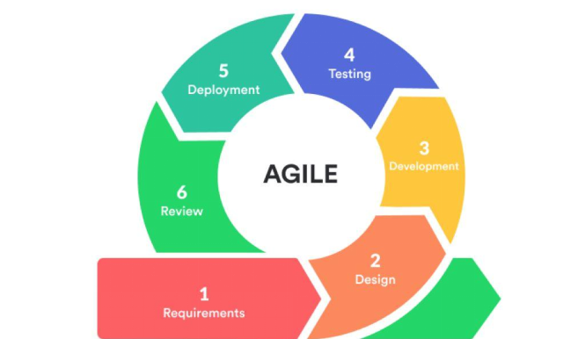
Figure 1. Agile Methodology
The project follows the Agile Methodology, ensuring a structured and systematic approach to the development and deployment of the AIMS. The agile process consists of the following phases:
- Requirements – The team works to finalize system features such as user registration, health monitoring, reports, and administrative controls. User stories and the product backlog are developed, defining the project scope and sprint priorities.

2.Design – The design phase of Medical Appointment and Scheduling System for Family Diagnostic Center, the UI/UX wire-frames, and database design are created. The team generates and ER diagrams to assist development, ensuring that the designs are user-friendly and functional.
3. Development – In the development phase, our team are in the process of making the system meets the client expectation and requirements. The project was divided and focused on specific features such as patient registration, appointment booking, notification system, and admin management. The team spend 1-5 weeks to planned, designed, developed, and tested different modules of the system. Feedback was gathered from users and team members to identify issues, improve functionality, and enhance user experience.
4. Testing - The testing phase of the Medical Appointment and Scheduling System for Family Diagnostic Center in this phase is done, the team conducted a trial run with users especially with the one who manage the Family Diagnostic Center to identify system errors, performance issues, and necessary feature improvements to ensures that the websites run smoothly.
5. Deployment - The implementation phase of the Medical Appointment and Scheduling System for the Family Diagnostic Center is now completed, the website has been uploaded to the Hostinger web host and already published on the official site.

6. Review - In the Review phase, our team verifies all performance of the medical appointment and scheduling services for family diagnostic center. So this phase to help us ensure that our system functions correctly and it aligns with the needs of both patient and staff. We review every part of the system and listen to users and the admin, plus take note of any problems or improvements required. In so doing, the team ensures that the system is user friendly and operates quietly and can be put into practice in a diagnostic center.

DATA FLOW DIAGRAM (DFD)
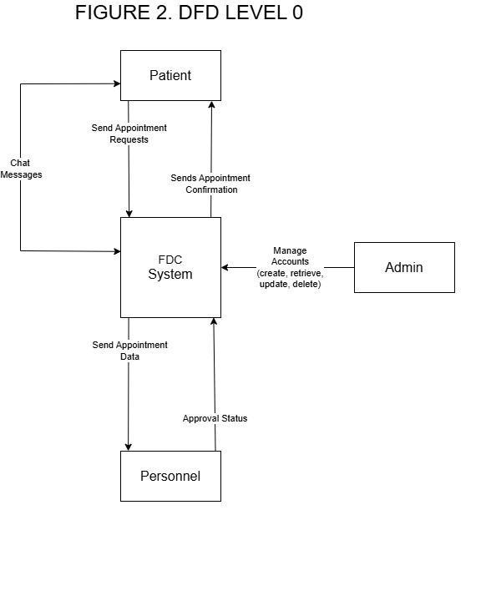

Figure 2. DFD Level 0

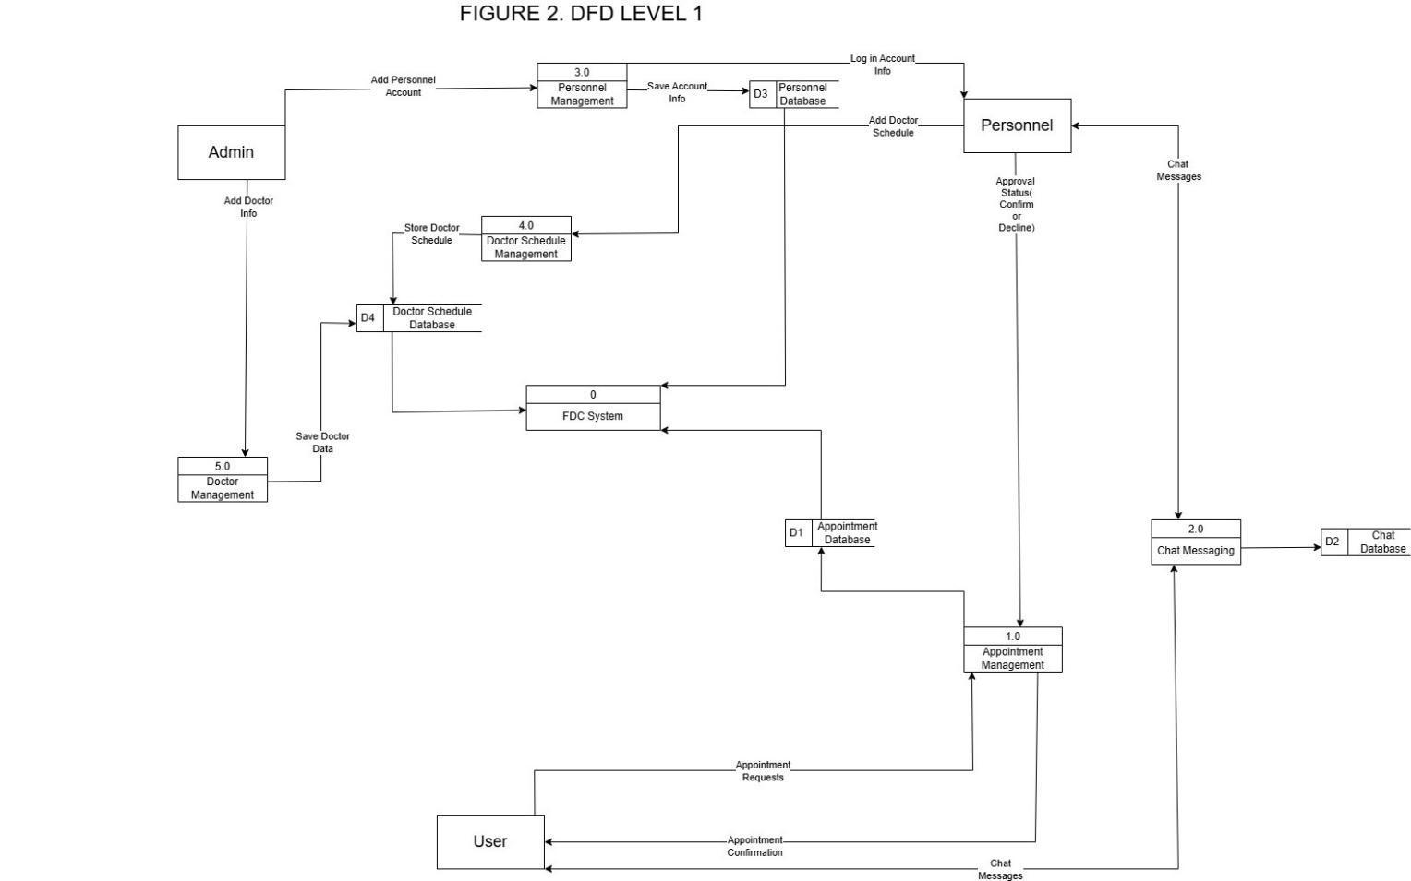
Figure 3. DFD Level 1
The figures above show the way information flows through the system. Figure 2 shows the overview of the entire system. Figure 3 highlights the main functions of the system.

ENTITY-RELATIONSHIP DIAGRAM (ERD)
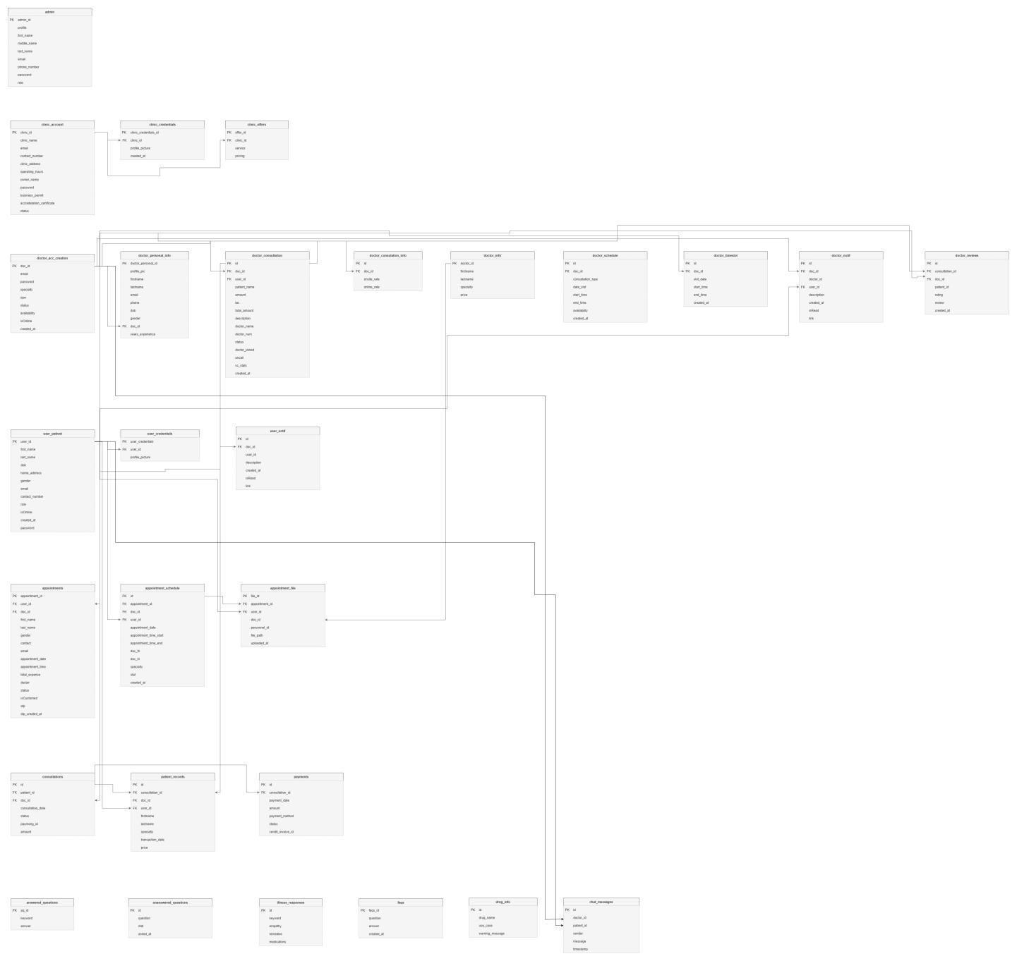

Figure 4. Entity Relationship Diagram
The figure above displays the visual representation for the database.

CHAPTER IV
Result and Discussion
This chapter presents the results and findings of the developed system. It highlights the system’s features, functionality, and performance based on the objectives set in the previous chapters. The results of system testing and user evaluation are discussed to determine the effectiveness and reliability of the system.
SYSTEM FEATURES
Home - provides an overview of the Family Diagnostic Center (FDC), which includes an online appointment booking system.
Key Features of the Family Diagnostic Center’s system, designed to make healthcare management easier and more efficient for both patients and staff:
HIPAA Compliant – Ensures patient data is protected and follows healthcare privacy laws.
Real-time Updates – Keeps all information instantly synchronized across devices.
Mobile Access – Allows users to view patient records and appointments anytime, anywhere.
Easy Integration – Connects smoothly with other existing healthcare systems.
Services Offer - patients can view all the services offered by FDC, including ultrasound, 2D echo, vascular studies, and DNA testing.
About FDC - the patients can see all the information needed about FDC so that they become aware of where it is located and where it started.

Family Diagnostic Center LANDING PAGE
Figure 4.1 serves as the initial interface between the website and the user.
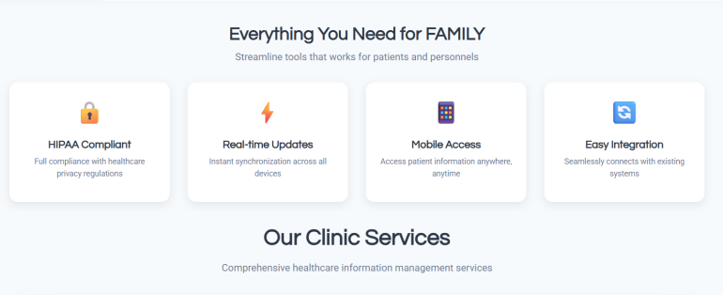
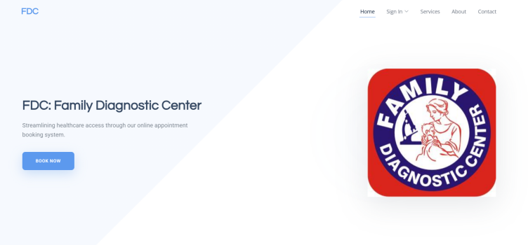
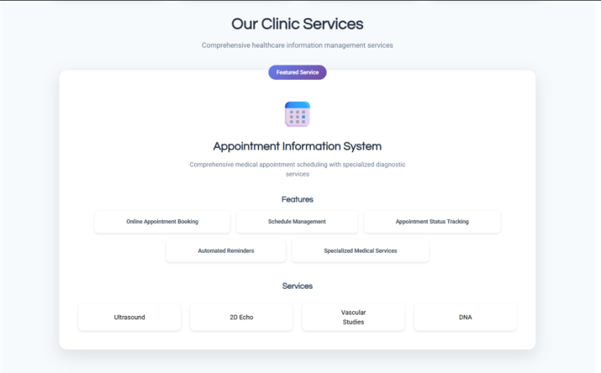
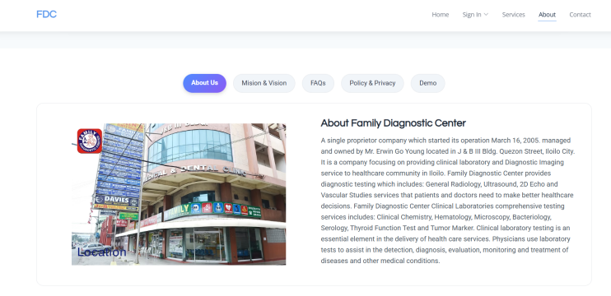
Figure 4.1 Landing Page

Family Diagnostic Center User Portal
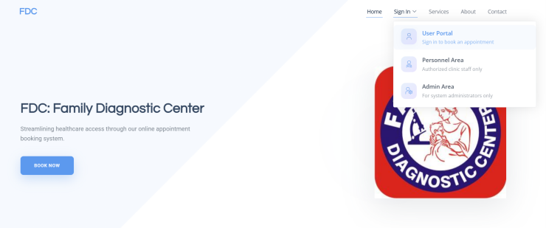
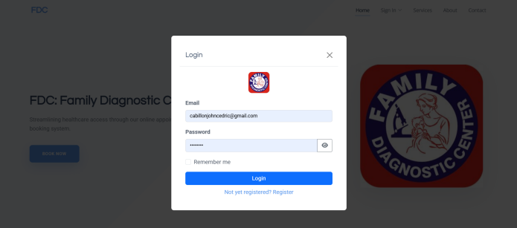
Figure 4.2 shows the patient can create an account to log in, and if they don't have one yet, they can register.
Figure 4.2 User Portal

Figure 4.3 shows once the patient has logged into their account, they will see this dashboard where they can view the "Book Appointment" section, which they can fill out with the necessary information required by FDC to make an appointment, along with all the details they need to know after booking.
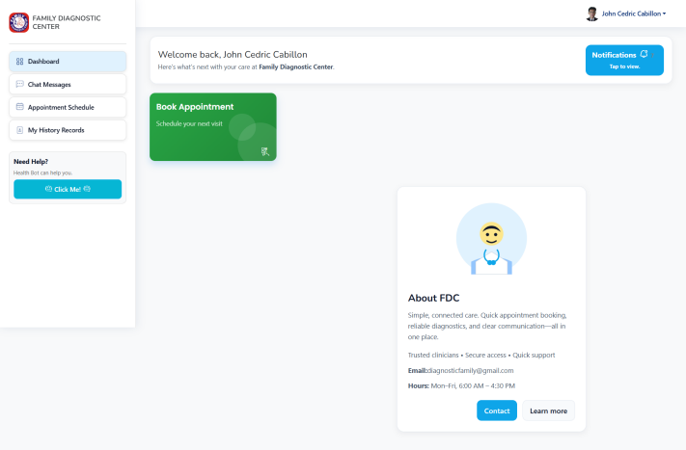
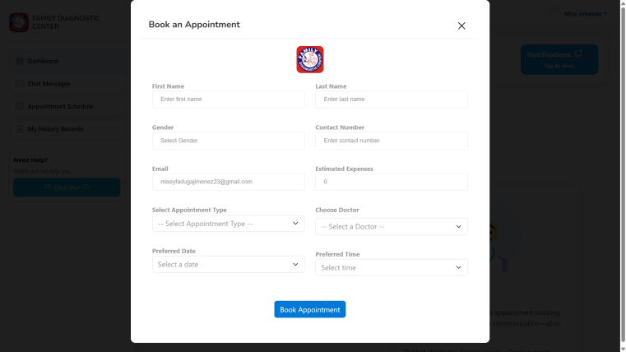
Figure 4.3 Dashboard

Figure 4.4 shows where patients can engage in conversations with doctors about what they want to ask regarding what they have booked and anything else, as long as both the patient and doctor is on the same platform.
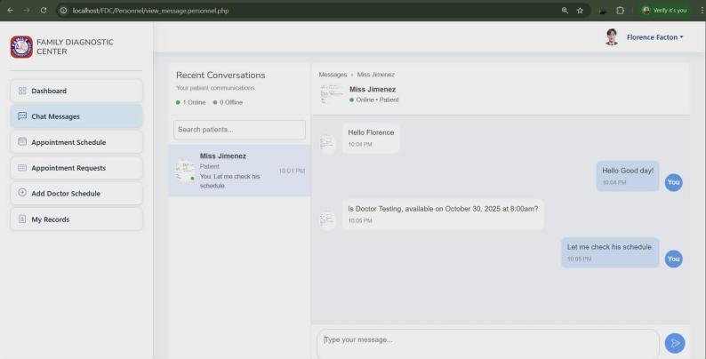
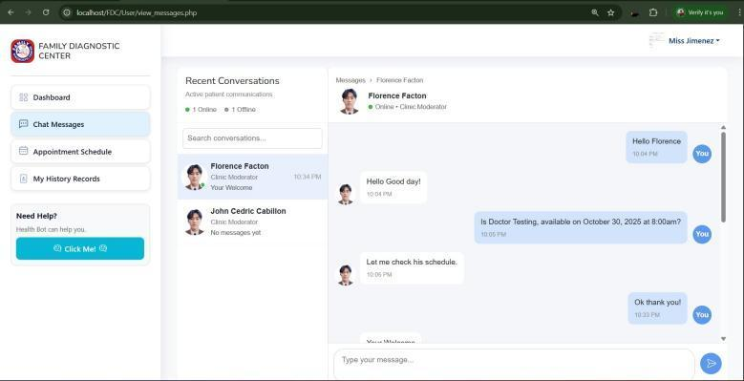
Personnel Side Patient Side
Figure 4.4 Chat Messeges

Figure 4.5 shows where patients can check their appointment schedule and at the same time check if their appointment has been approved or declined, they can also see the upcoming schedules and available schedules for that day.
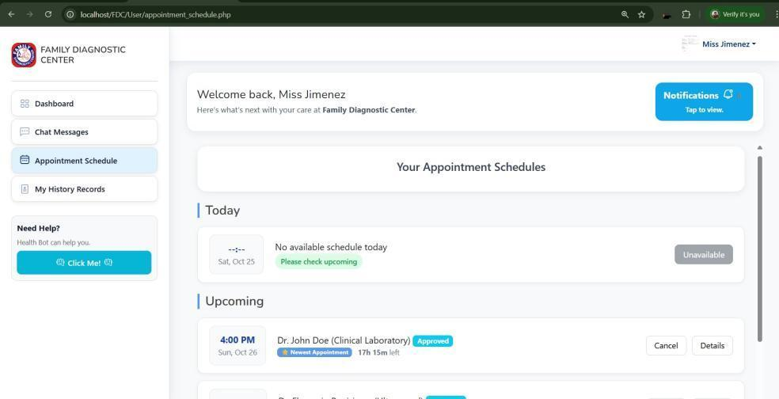

Figure 4.5 Appointment Schedule

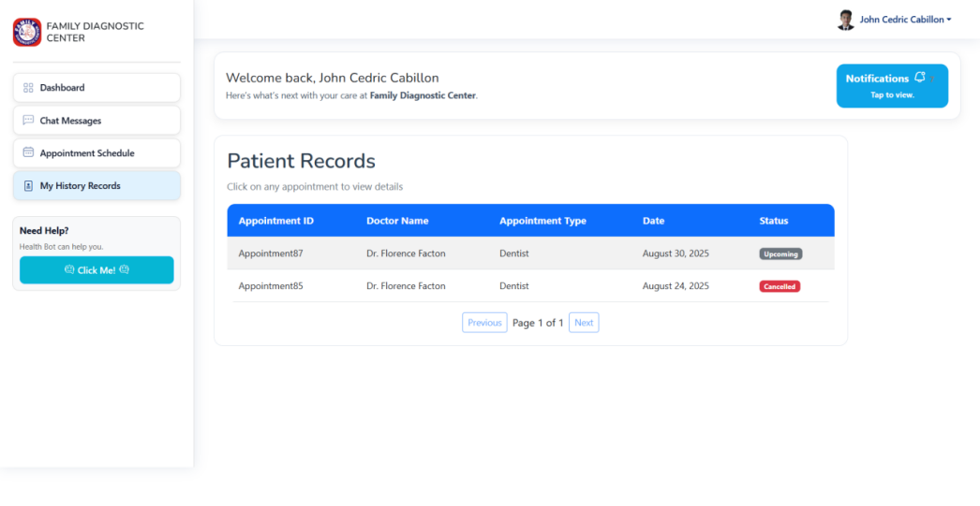
Figure 4.6 The Patient History Records section shows where you can view the appointment details, including the appointment ID, doctor’s name, appointment type, date, and status.

Figure 4.6 Patient Records

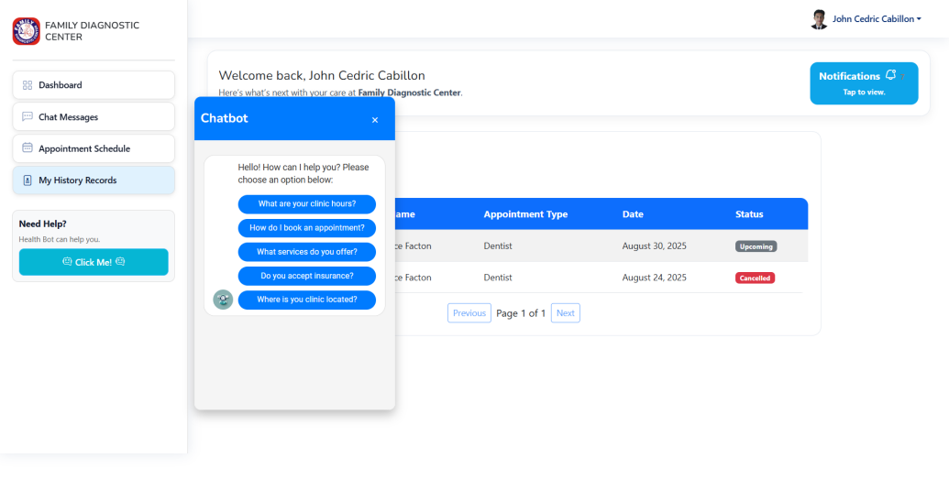
Figure 4.7 shows the Chatbot, where patients can ask FAQs related to the FDC. The moderator can respond to these questions and also has the option to update or delete FAQs if changes are needed.

Figure 4.7 Chatbot

Figure 4.8 shows the Notifications section, where patients are notified when they have a scheduled consultation with the doctor.
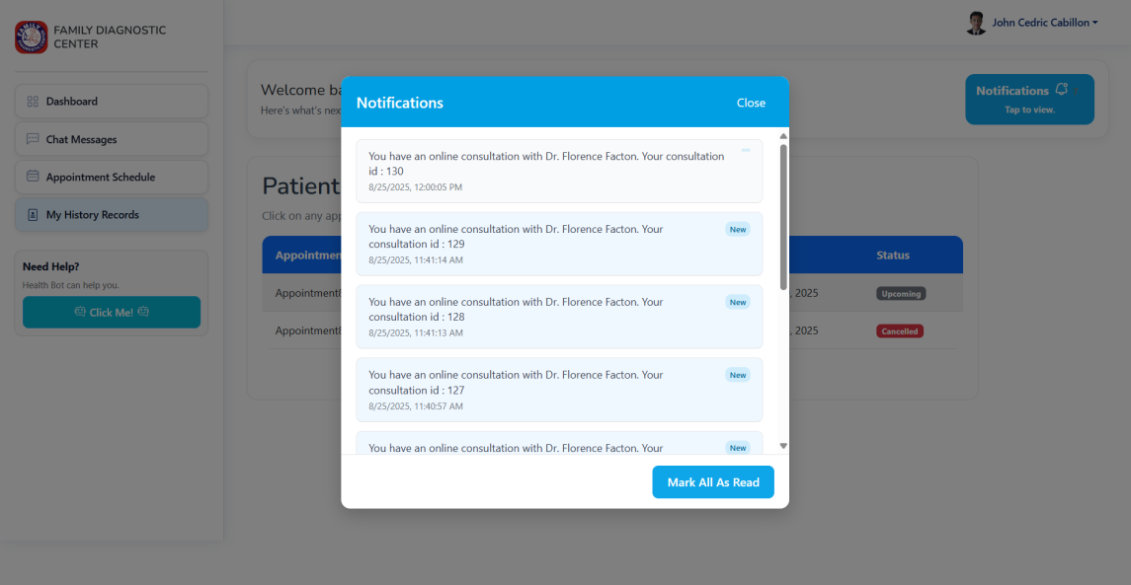

Figure 4.8 Notifications
Family Diagnostic Center Personnel Portal
Figure 4.9 shows the doctor's side where they can log in their account.
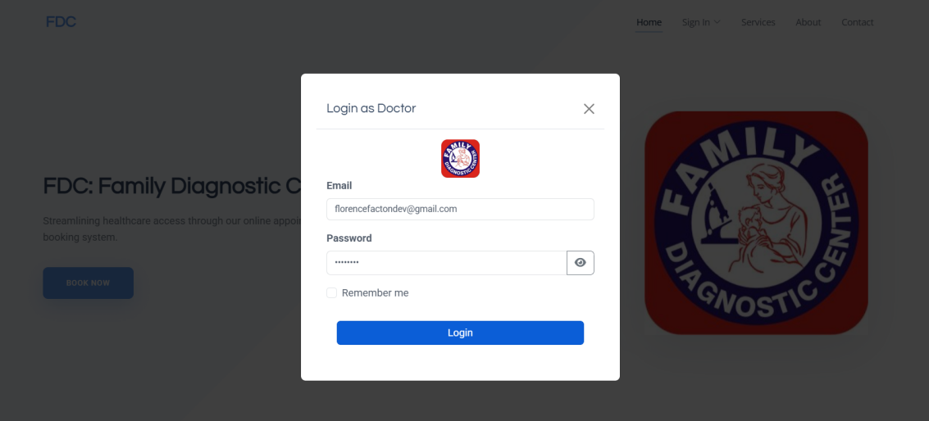

Figure 4.9 Doctor Login

Figure 4.10 shows the “dashboard” of Family Diagnostic Center in the personnel portal, including chat messages, appointment schedule, appointment request, add doctor schedule and my records.
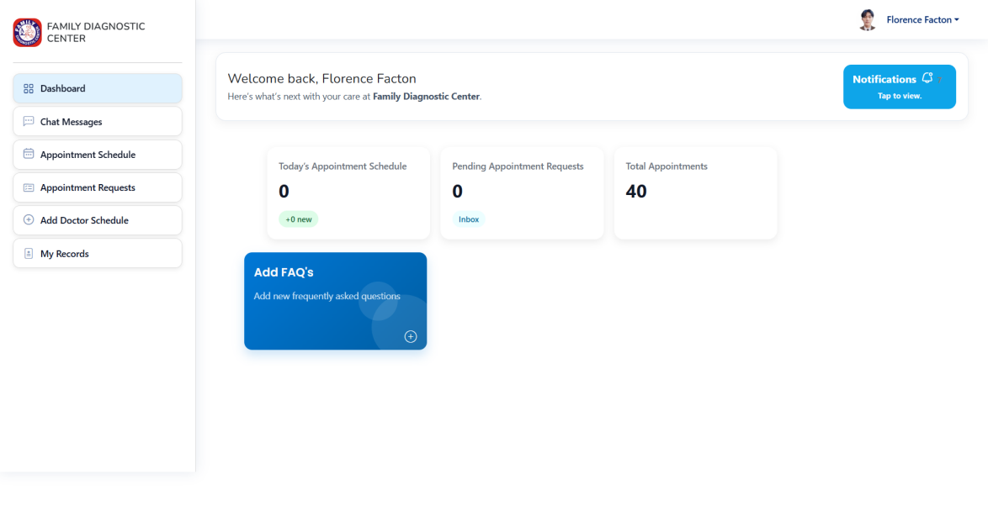

Figure 4.10 Dashboard
Figure 5.0 shows the “chat messages” of patients to the available assigned personnel, for more and clear information.
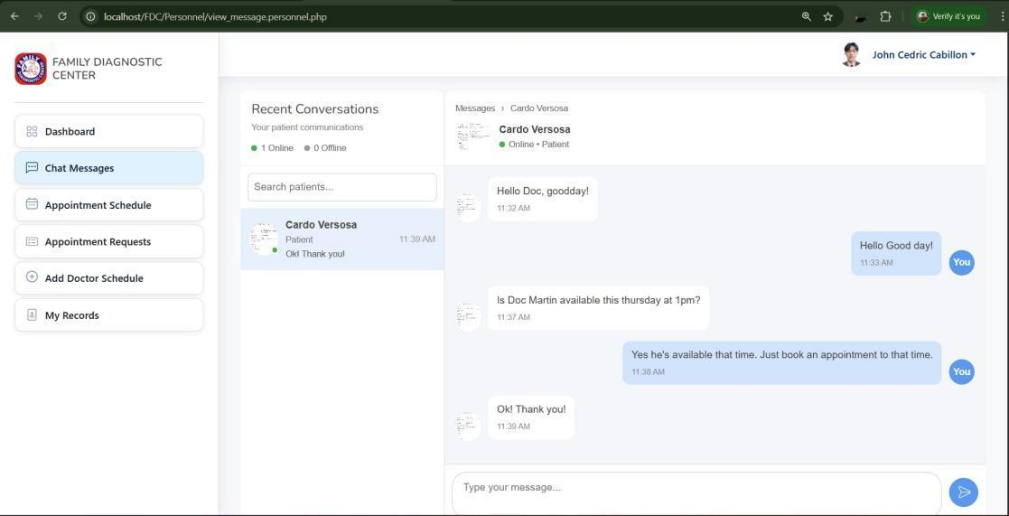

Figure 5.0 Chat Messages

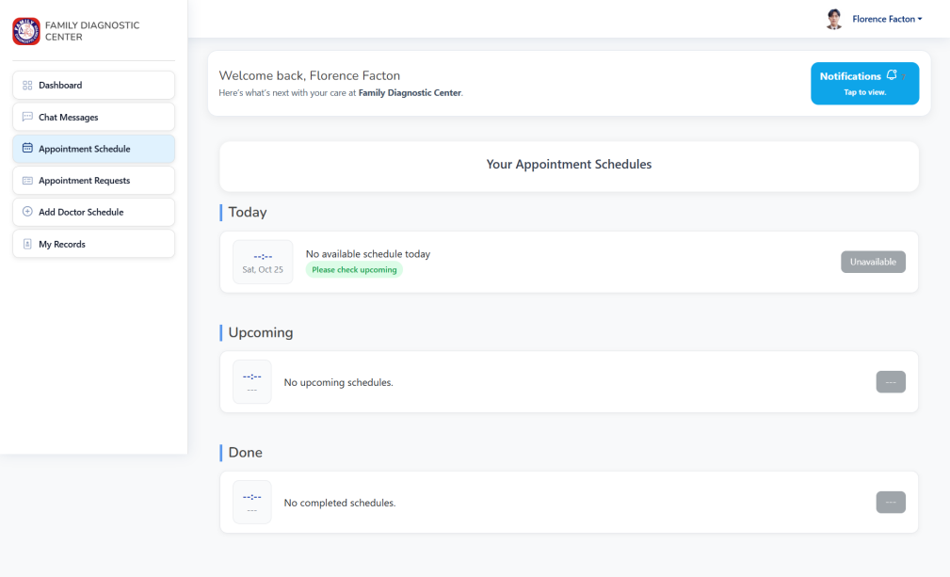
Figure 5.1 shows “Appointment Schedule” where assigned personnel can check their schedule today, upcoming schedule and the complete schedule.

Figure 5.1 Appointment Schedule
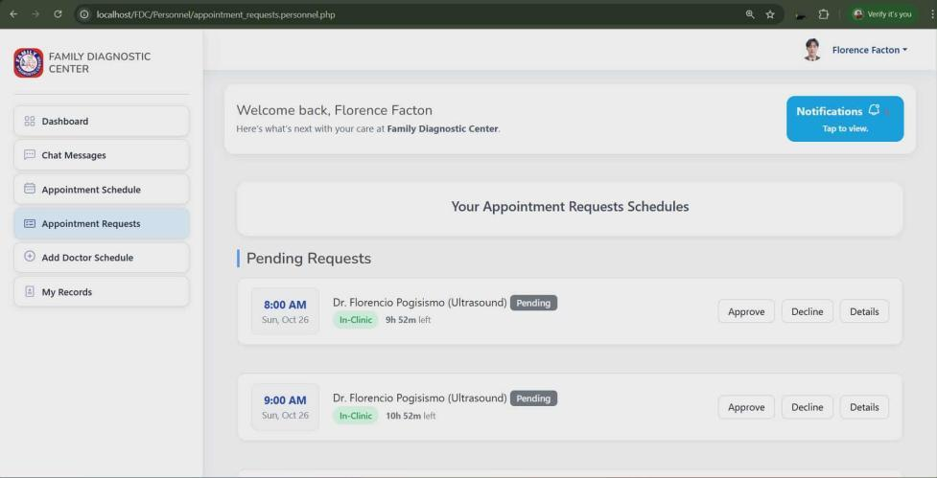
Figure 5.2 shows the “Appointment Request” . This feature displays the Appointment Request page, where assigned personnel can quickly view all patient requests, especially the pending ones. They can then decide whether to approve or decline each request, along with reviewing the details.

Figure 5.3 Appointment Request

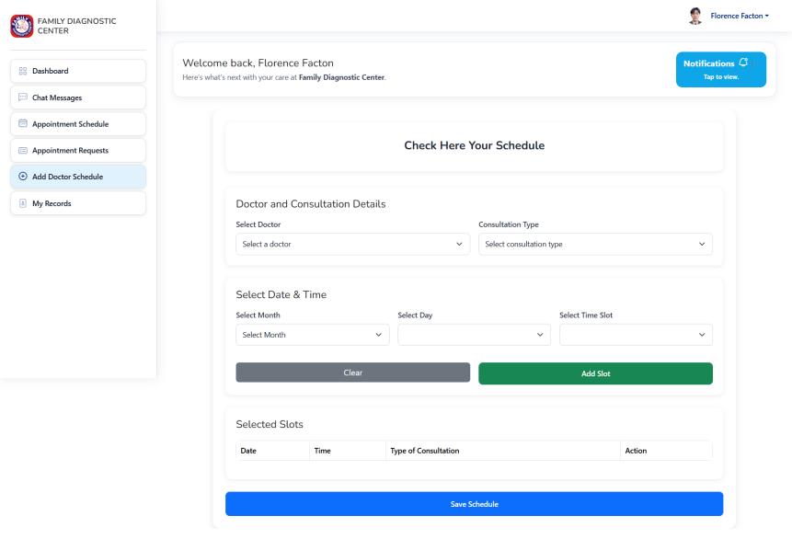
Figure 5.4 shows the “Add Doctor Schedule”, in this feature, the assigned personnel can edit their availability by inputting the necessary information and saving their schedule.

Figure 5.4 Add Doctor Schedule
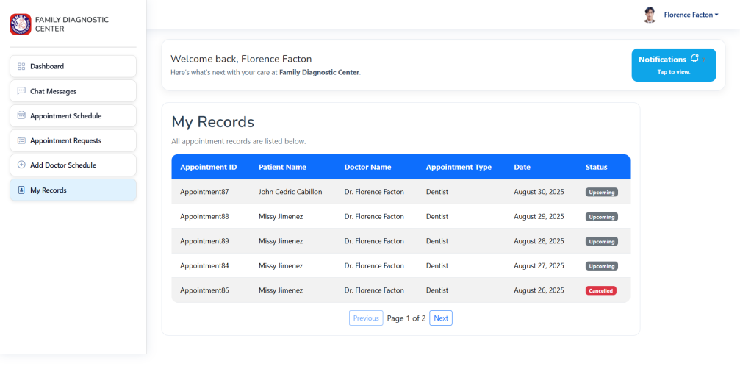
Figure 5.5 shows the “My Records” section of the Family Diagnostic Center system. It lists all appointment details including the Appointment ID, Patient Name, Doctor Name, Appointment Type, Date, and Status. The records show upcoming and cancelled appointments of patients.

Figure 5.5 My Records

Figure 5.6 shows the “Notification” for Personnel Side, where they will be notified for the upcoming appointments of the patient.
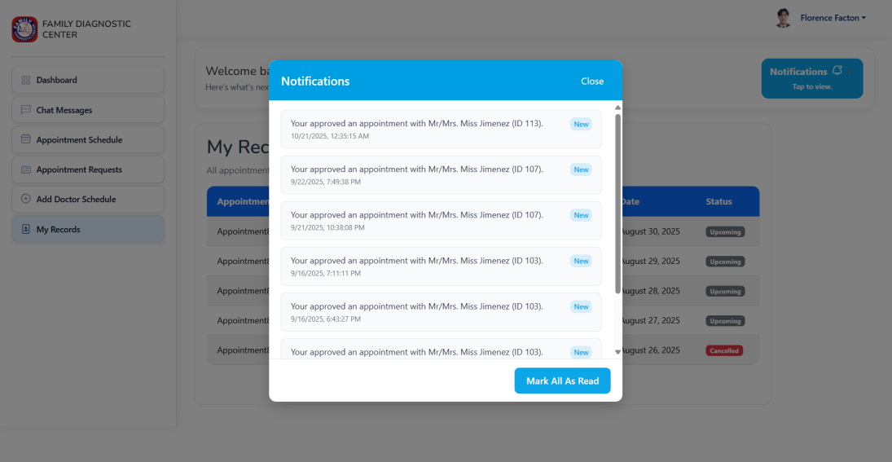

Figure 5.6 Notification

Family Diagnostic Center Admin Portal
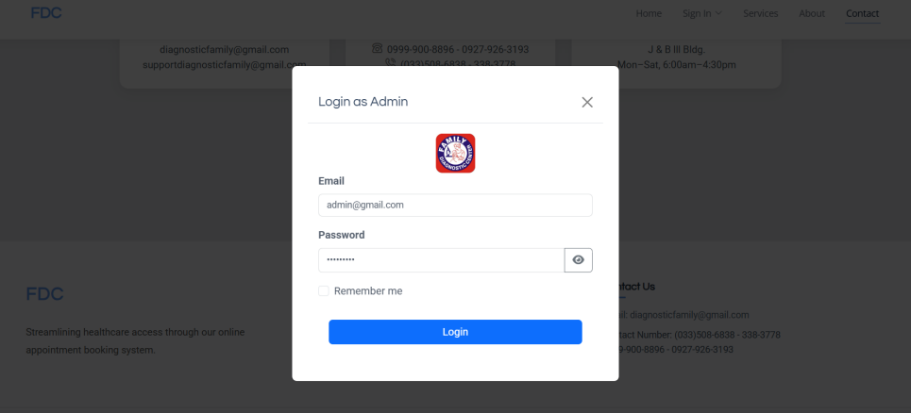
Figure 5.7 shows the “Admin Login” where the Admin or moderator need to sign in or login their account.

Figure 5.7 Admin Login

Figure 5.8 shows the “Dashboard” of Family Diagnostic Center where the admin can quickly view the total revenue from last week and today, along with the total appointments, total users, and total doctors. They can also see the monthly appointments per specialty, the breakdown of doctor performance, and appointments by type. And lastly they can check the analytics review and export it for their purposes.
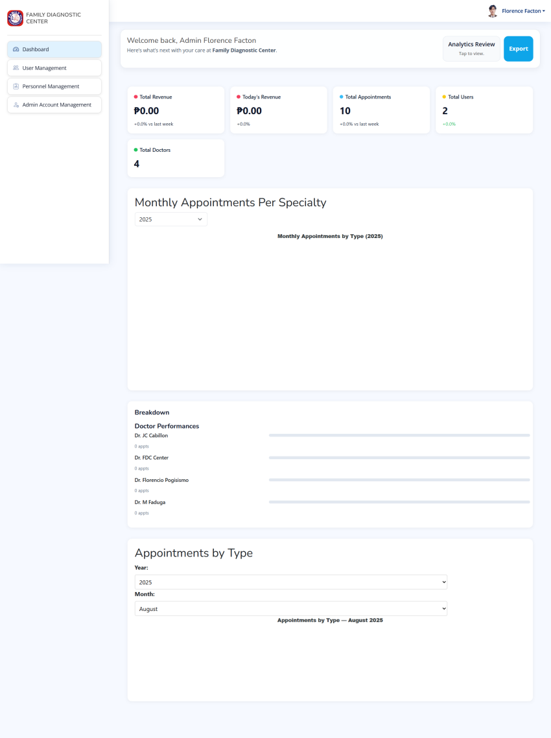

Figure 5.8 Dashboard

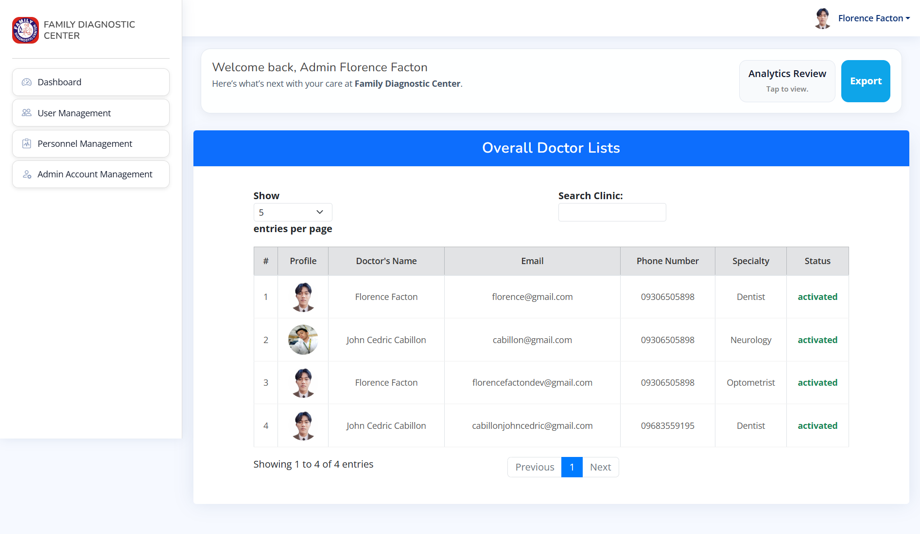
Figure 5.9 shows the “User Management” where the admin can easily view the overall list of doctors who have profiles, including the doctor name, email, phone number, specialty, and the status of whether they are activated or not.

Figure 5.9 User Management
Figure 5.10 shows “Personnel Management” where the admin can add personnel and doctors, view the list of personnel and list of doctors, and this can also be downloaded in PDF format.
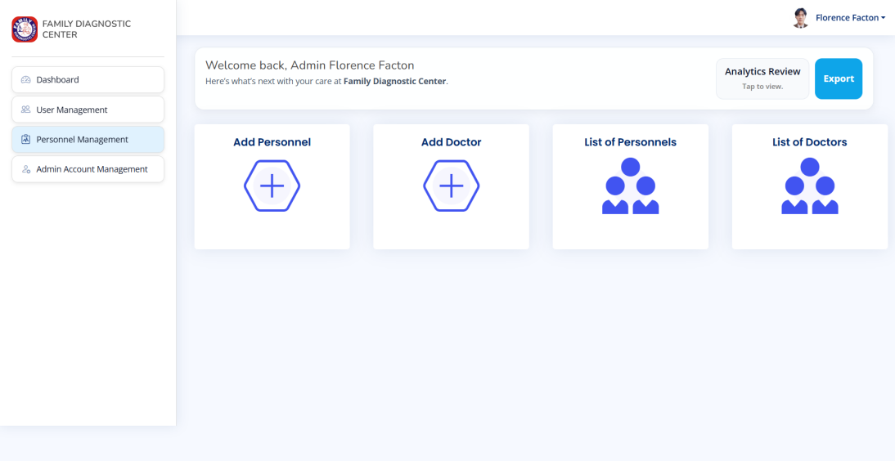

Figure 5.10 Personnel Management

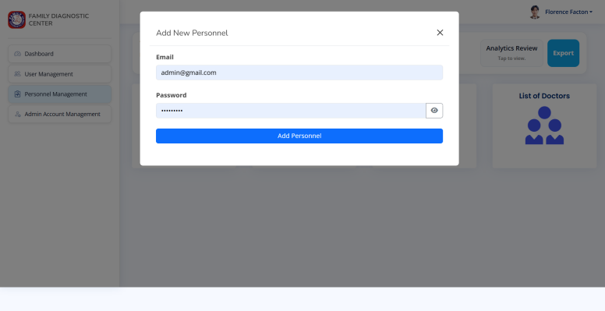
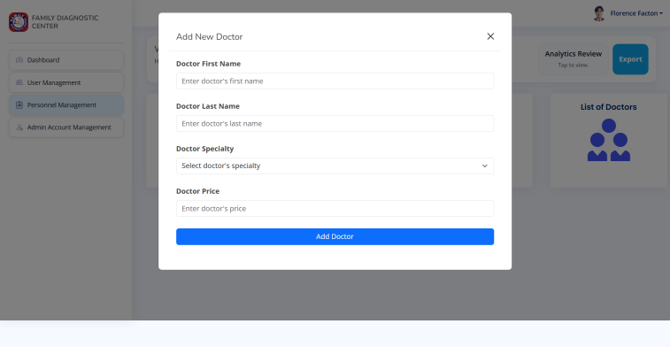
Figure 6.0 Add New Personnel Figure 6.1 Add Doctors

Figure 6.2 List of Personnel Figure 6.3 Doctor List

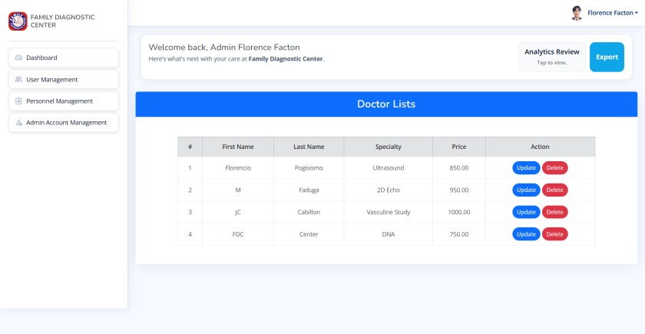

Implementation Challenges
During the development of "Medical Appointment and Scheduling System for Family Diagnostic Center" a web-based platform designed to streamline the management of patient appointments and scheduling, several implementation challenges arose that tested our team's adaptability and technical skills. These were documented through weekly progress logs, session and role management, AJAX/JS issues, UX and alert messages, Dynamic form population with DB data and Database integrity and consistency, Time management, Color Palette, Prototype/Layout, Media Query and Frontend and Backend connection. Below, we outline key challenges, their resolutions, and insights gained.
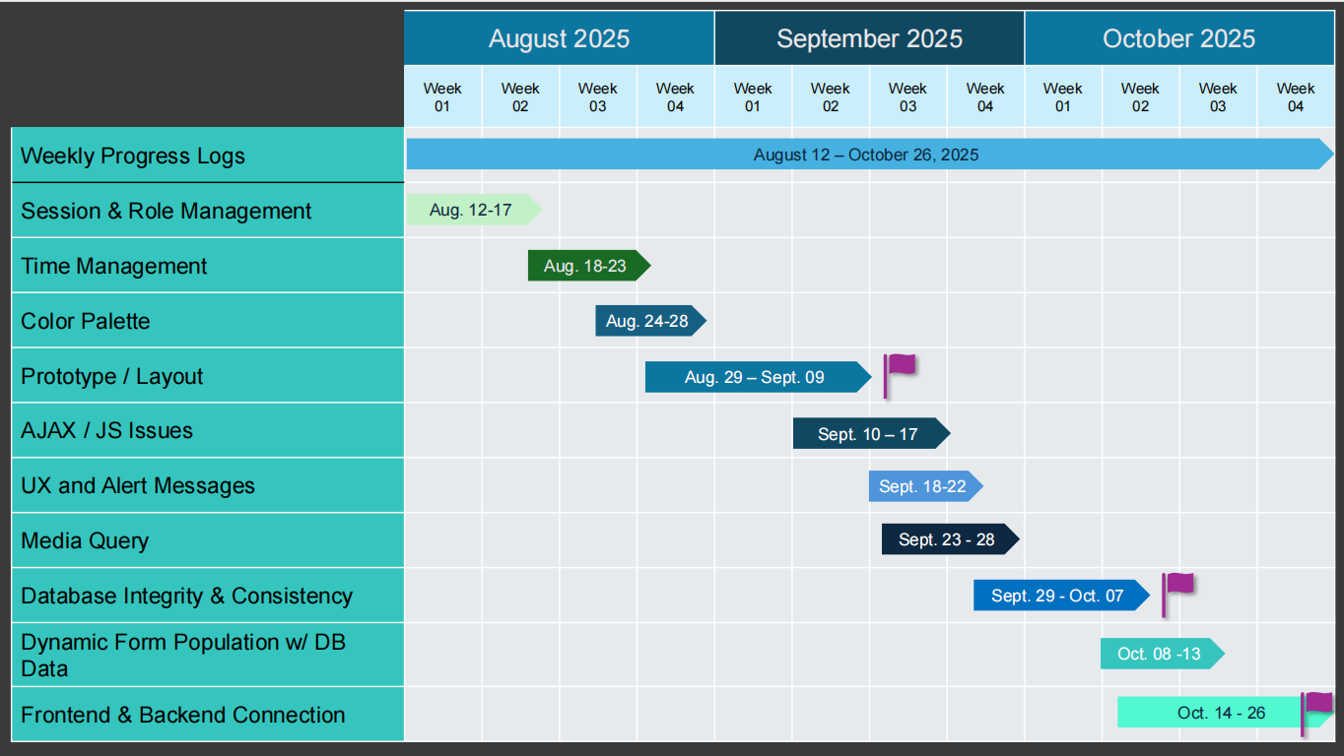

User Feedback
When we presented it to our client, they liked the system itself. At the same time, they suggested keeping the system but changing the focus to only booking appointments, as that's what they really need. They also removed telemedicine because to them it is not useful ; their main focus is on booking an appointment since they're a diagnostic center they provide medical diagnostic procedures. The primary goal is to avoid patients having to visit and inquire about available times or what services they offer. The team further enhanced it by displaying the available times for each service offered, to prevent confusion and delays for patients, and to avoid long queues, especially for senior citizen patients. They also added DNA to the services, and booking appointments is essential because some samples need to be brought in. Finally, they want results to be viewable and downloadable as PDFs by the clients themselves, making it easier for clients to access their results and send them via email. However, clients can still choose to pick up their results directly at the clinic if they prefer.

Medical Appointment and Scheduling System for Family Diagnostic Center
Instructions: On the scale of 1 to 5 where 5 is the highest and 1 is the lowest, please put a check (/) on the following statements based on your experience using MASSFDC.
SCALE | DESCRIPTION
5 | Strongly Agree
4 | Agree
3 | Neutral
2 | Disagree
1 | Strongly Disagree
Survey Questionnaires for Admin
No. | Statement | 5 | 4 | 3 | 2 | 1
1 | Is the MASSFDC System makes managing patient appointments easier?.
2 | Does the system help to reduce manual work in scheduling appointments?
3 | Does the system improve the efficiency of managing patient records?
4 | Using the MASSFDC system helps prevent appointment conflicts or double bookings?
5 | Is the interface of the MASSFDC easy to understand and use?
6 | The system helps staff respond to patient appointment requests faster?
7 | Does the system improve the overall workflow of the diagnostic center or clinic?
8 | The MASSFDC helps organize and store patients information effectively?
9 | Does the System reduce the need for patients to come to the center just to schedule appointments?
10 | Overall, MASSFDC system is useful for managing diagnostic center/clinic operations.

Medical Appointment and Scheduling System for Family Diagnostic Center
Instructions: On the scale of 1 to 5 where 5 is the highest and 1 is the lowest, please put a check (/) on the following statements based on your experience using MASSFDC.
SCALE | DESCRIPTION
5 | Strongly Agree
4 | Agree
3 | Neutral
2 | Disagree
1 | Strongly Disagree
Survey Questionnaires for Patients
No. | Statement | 5 | 4 | 3 | 2 | 1
1 | The MASSFDC System makes it easy for me to book an appointment.
2 | Booking an appointment online is easier than going to the diagnostic center.
3 | This system helps me save time and effort when making an appointment.
4 | The steps for booking an appointment are easy to follow.
5 | MASSFDC shows clear available schedules for appointments.
6 | I feel comfortable using the MASSFDC system to book an appointment.
7 | Using MASSFDC helps me avoid waiting in line at the center.
8 | The system helps me keep track of my appointments.
9 | I would like to use the system again for future appointments.
10 | Overall, MASSFDC system is helpful and convenient for me.

Comparison to Other System
The Medical Appointment and Scheduling System for Family Diagnostic Center is faster, more accurate, and more convenient to patients than the traditional manual scheduling. Other studies of digital appointment and booking systems also observed reduced waiting times, fewer instances of conflicting bookings, as well as improved access for patients and health staff. These results match the performance of what we have proposed and thus indicate that replacing human factors with automatic processes for managing appointments is effective in terms of optimizing appointment handling, decreasing chances of errors and improving all-over quality delivered from diagnostic services within centers.

CHAPTER V
Summary, Conclusion and Recommendation
5.1 Summary
This study aims to design and develop a web-based Medical Appointment and Scheduling System for the Family Diagnostic Center that will simplify the process of booking, managing, and monitoring diagnostic appointments to reduce walk-ins and manual logbooks, often result in long queues, miscommunication, double bookings, and wasted time for both patients and medical staff. The project follows the requirements, design, development, testing, deployment and review.
The system successfully met its objectives and proved to be an effective solution for modern medical appointment and scheduling system needs.
5.2 Conclusion
Based on our testing, the system turned out to be applicable and reliable for the appointment process. It cuts down on walk-ins and those old manual logbooks that often led to long queues, miscommunication, and double bookings. It really helps patients manage their appointments way faster and easier. Client’s feedback confirmed that the system was easy to use and made scheduling tasks more manageable for both patients and staff.

5.3 Recommendation
Based on the development and evaluation of the project, the following recommendations are made:
- Remove the Telemedicine Aspect - The client wants to remove this part because it is not necessary, as their main requirement focuses more on booking appointments and scheduling systems.
- Client Add Another Procedure - The client adds another procedure, including clinical laboratory, DNA testing, ultrasound, ECG, and X-ray to help users or patients become more familiar with all the services they offer.
- Update/Delete Personnel Side - The personnel side should have update and delete features so that the moderator can edit and manage which personnel are active or inactive.

Final Thoughts
The Medical Appointment and Scheduling System for Family Diagnostic Center developed for the Family Diagnostic Center aims to make healthcare more accessible, organized, and patient-centered. By clarifying the process of booking and managing appointments, the system not only improves efficiency for staff but also provides a smoother and more comfortable experience for patients. Lastly, this project reflects how technology can play a meaningful role in delivering better and more responsive healthcare services for the community.

CHAPTER VI
Appendices
Screenshots
Curriculum Vitae
Grammarian Certificate

